Request a Room Reservation
Last Updated 10/14/2021
All room reservation requests are submitted and processed through the Astra system at the following link: https://www.aaiscloud.com/UCAMerced/Portal/GuestPortal.aspx. For a full listing of UC Merced Event Scheduling Practice and Procedures, please view the following link: http://registrar.ucmerced.edu/services/room-reservations.

- Select the Events tab to request an event or select “Request Event” below Astra Holidays and Announcements. Do not sign in on the top right corner. Your contact information will be requested later.
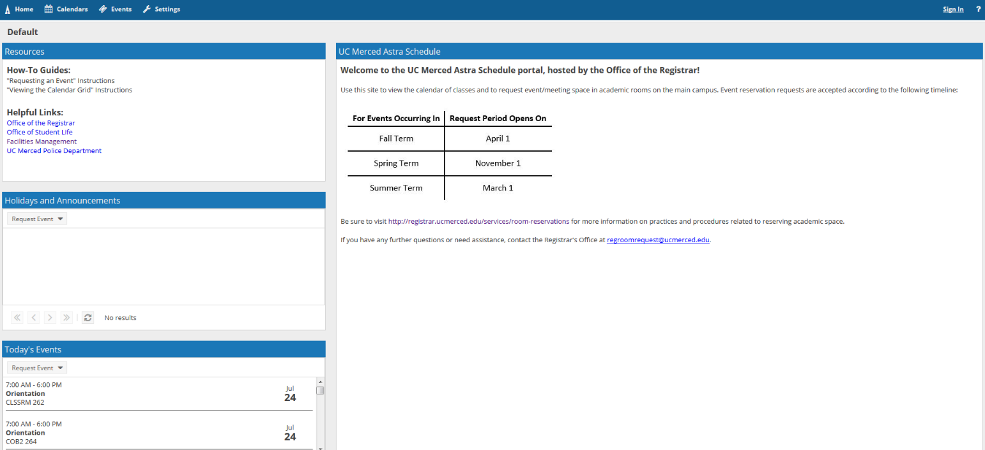

- Select the appropriate Event Request Form.
  - Use the drop down to select the correct form for your request.
  - You will be redirected to a fillable web form to fill out with your event request details.
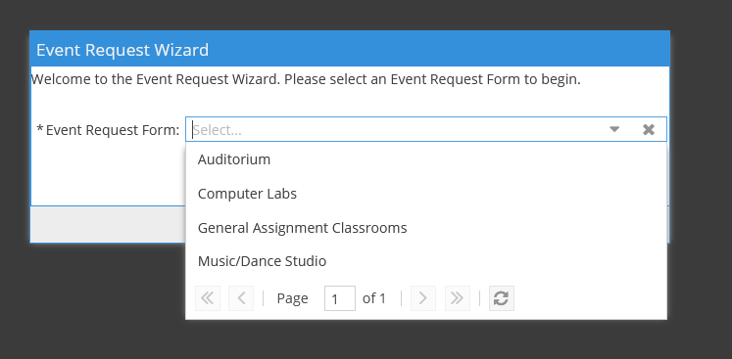

- Please complete the fillable web form with all pertinent information regarding the room reservation request (see screenshot on the next page).
  - Name of Club, Organization, Department or School
*Please note, in the event the requesting group is a club or organization, the group must be recognized through the Office of Student Involvement (listed on https://catlife.ucmerced.edu/) in order for the event request to be approved.
  - A descriptive title of the event and any details related to the event that indicate requirements for the room/reservation.
*If using the computer lab request form, please include the nature of the event and any required software.
  - Number of attendees expected
*In the event requested room has a maximum capacity that cannot accommodate the number of expected attendees, the event may be declined if no alternative appropriately sized rooms are available.
  - Indicate whether your event will have food. *Note that food is not allowed in computer labs.

- Select “Add a Meeting” and determine whether your meeting is a single, multiple, or recurring meeting.
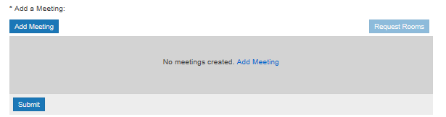

  - Single Meetings

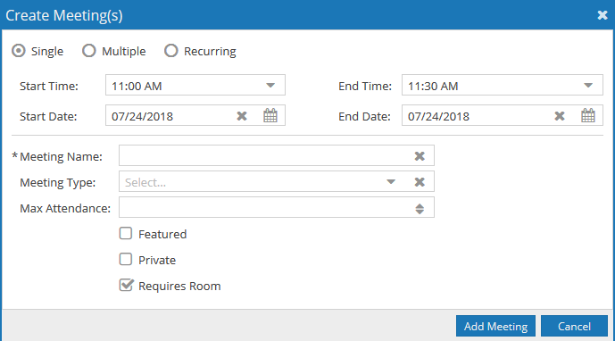

    - Single Meetings can be created by selecting “Single”.
*Note that if you would like to reserve a room for multiple dates you can use the Multiple Events option instead.
    - Provide meeting name, meeting type and max attendance.
    - Leave the “Requires Room” flag checked.
    - Once the appropriate meeting dates/times have been adjusted, select “Add Meeting”.

  - Multiple Meetings

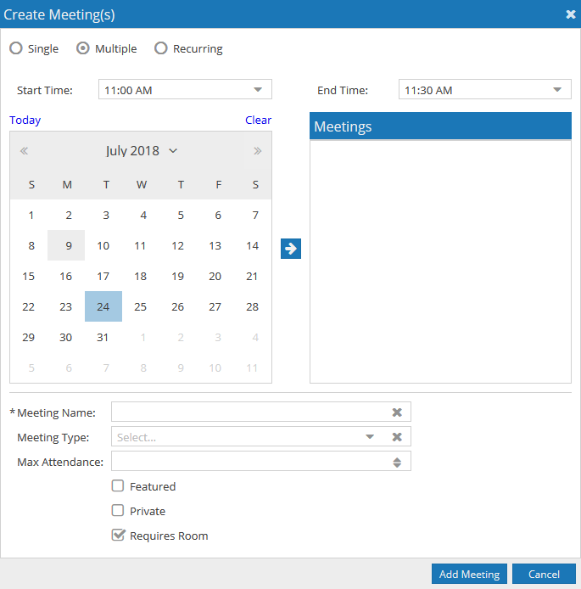
    - Multiple “single meetings” can be selected by highlighting the dates needed (e.g. three meetings within a two week span, etc.) and selecting the arrow. The selected calendar dates for single meetings will be highlighted in blue. To remove dates, click on the blue highlighted date and the blue box will be erased.
    - In the event the set/group of meetings takes place at different times and dates: set the time for the first meeting, select the appropriate dates, select the arrow and then repeat the process for the remaining meetings (be sure to remove the date from the initial meeting to reset the meeting options).
    - Provide meeting name, meeting type and max attendance.
    - Leave the “Requires Room” flag checked.
    - Once the appropriate meeting dates/times have been adjusted, select “Add Meeting”.

  - Recurring Meetings

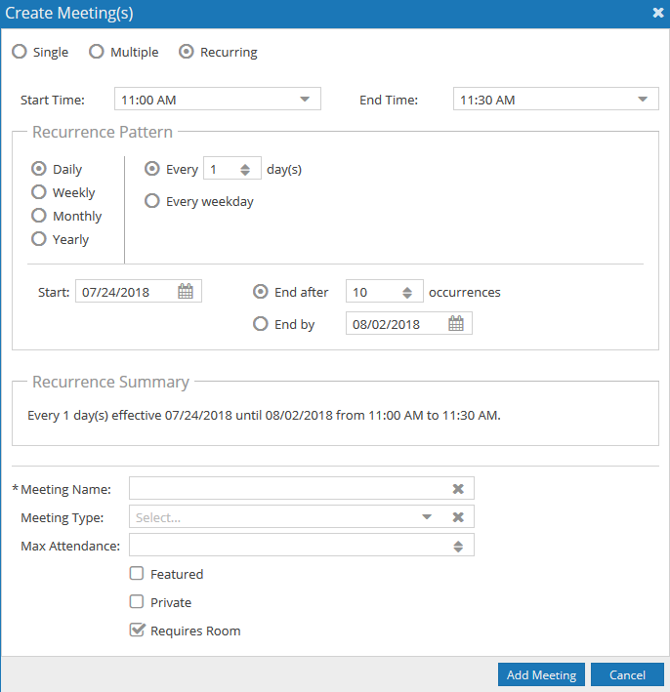
iii

ii
i
    - Weekly recurring meetings can be requested by selecting the recurring option.
    - Select the weekly option and select the days and times you would like to have a weekly meeting on.
    - You can select the meetings to end after a certain number of occurrences or to end by a specific date (such as the end of term).
    - Provide meeting name, meeting type and max attendance.
    - Leave “Requires Room” flag checked.
    - Once the appropriate meeting dates/times have been adjusted, select “Add Meeting”.

- The meeting(s) will populate in the box.
  - If the dates and times are correct, select “Request Rooms”.
  - If you select the X, this will delete your request.
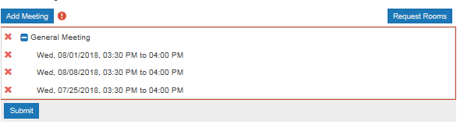
- The Assign Room box will populate and provide a listing of rooms (see image on next page).
  - Gray/White – the room is available for one and/or all of the meeting dates
  - Yellow – indicates the number of meetings the room is available for some of the meeting dates.
  - Red – the room is not available to be reserved
  - Green – indicates the rooms you have selected

- Depending on the nature of the event, the filter at the top left of the Assign Room box may need to be adjusted to the following: General Reservations (most common), Video-conference, or Weekend Rooms (Card Access).

- Select the room(s) to be requested for the meeting and once the selection has turned green, select “Ok”.
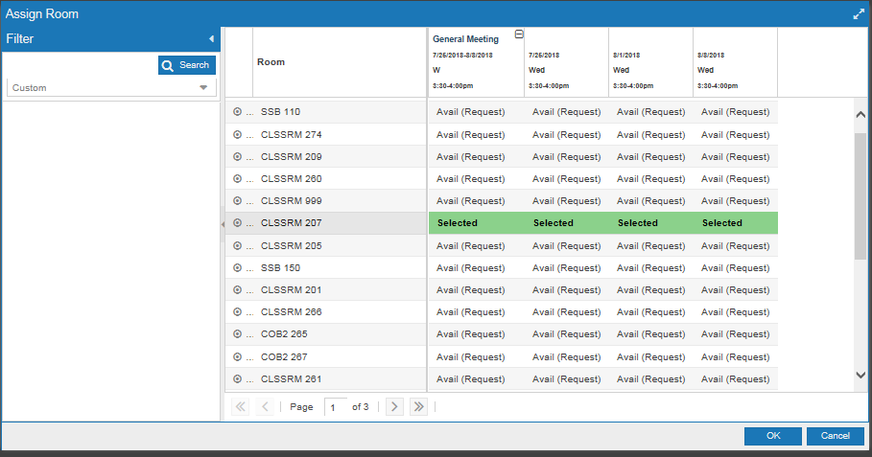

- The meeting(s) will then display the room assigned to the room reservation request.
  - Once the meeting(s) have been assigned a room to be requested and all required information has been inputted into the web form, select “Submit”.
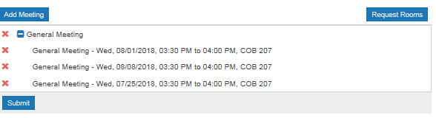
- Select “Done” and Astra will return you to the home page where you are able to submit additional requests. However, to expedite processing, if there are multiple meetings that are part of the same event, please submit these room reservations under one request.
- An email will be sent through the Astra system to the email you provided in the web form, confirming that we have received your request. Once your event request has been reviewed and processed, an additional email (event summary) will be sent indicating the status of your event.
- Please contact regroomrequest@ucmerced.ed with any questions, or in the event you would like to cancel your room reservation (please respond back to regroomrequest@ucmerced.edu with the event summary e-mail).

